UNIT 6
Lesson 3 – AROUND CROATIA

- 1 a) Look at the pictures. Listen, point and say.
Pogledaj sličice. Poslušaj, pokaži i reci.
HIGH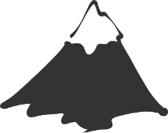 HIGHER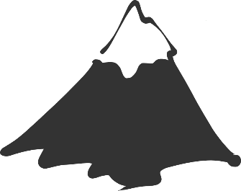
VISOK VIŠI

LONG LONGER
DUGAČAK DUŽI
SMALL 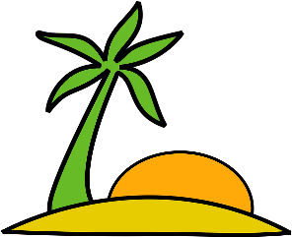 SMALLER
MALEN MANJI

b) Listen to you teacher read the questions.
Circle the correct answer.
Fill in the sentences with the missing words.
Poslušaj svog učitelja kako čita pitanja. Zaokruži točan odgovor.
Nadopuni rečenice riječima koje nedostaju.
Mt. Everest

2 Which one is HIGHER? 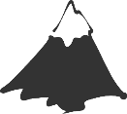 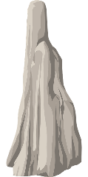
Mt. Elbrus
HIGH HIGHER
Koja je viša? VISOK VIŠI

Mt Elbrus is high, but Mt Everest is higher.
Mt Elbrus je visok, ali Mt Everest je viši.

the Danube
the River Volga
3 Which one is LONGER?
Koja je duža?

The Danube is ______ but the the River Volga is ________ .
Rijeka Dunav je dugačka, ali rijeka Volga je duža.
Prvić
Jabuka
4 Which one is SMALLER? 
Koji je manji?

The island of Prvić is _______, but the island of Jabuka is _________ .
Otok Prvić je malen, ali otok Jabuka je manji.

2 a) Look at the pictures. Listen, point and say.
Pogledaj sličice. Poslušaj, pokaži i reci.
HOT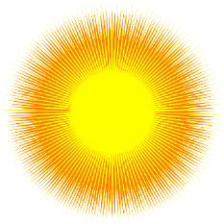 HOTTER 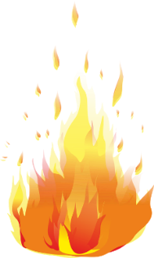
VRUĆ VRUĆI

b) Read the question. Circle the correct answer.
Pročitaj pitanje. Zaokruži točan odgovor.

Where is hotter?
Gdje je vruće?
It`s hotter in Dalmatia than in Lika.
Vruće je u Dalmaciji nego u Lici.

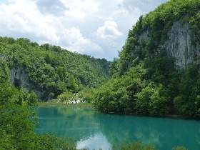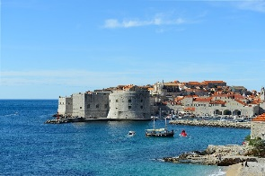
Lika Dalmatia

- 3 a) Look at the pictures. Listen, point and say.
Pogledaj sličice. Poslušaj, pokaži i reci.
OLD 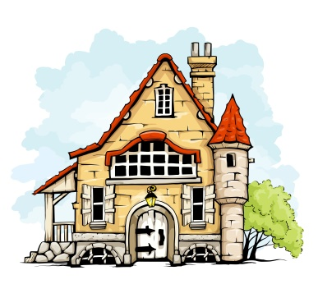 OLDER 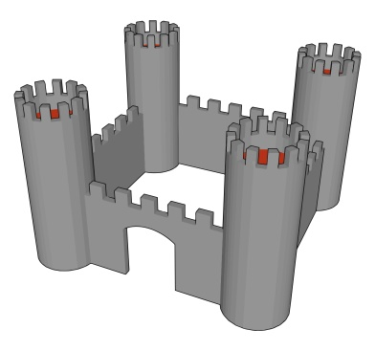
STAR STARIJI

b) Read the question. Circle the correct answer.
Pročitaj pitanje. Zaokruži točan odgovor.

Which one is older?
Split is older than Zagreb.
Split je stariji grad od Zagreba.

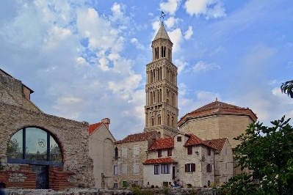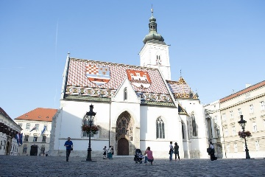
Split Zagreb

- 4 a) Read the sentences.
Answer the question. Circle the correct answer.
Pročitaj rečenice. Odgovori na pitanje. Zaokruži točan odgovor.

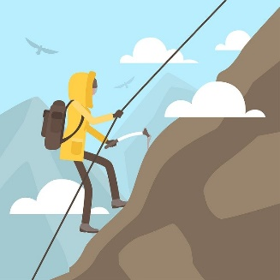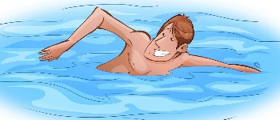
It's easier to climb a mountain than to swim across a river.
Lakše je popeti se na planinu nego preplivati rijeku.

What is easier?
Što je lakše?
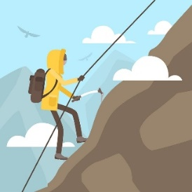
to swim across a river to climb a mountain

- 5 a) Look at the pictures. Listen, point and say.
Pogledaj sličice. Poslušaj, pokaži i reci.

b) Read the sentences. Answer the question.
Circle the correct answer.
Pročitaj rečenice. Odgovori na pitanje. Zaokruži točan odgovor.
It’s good to swim in the sea. 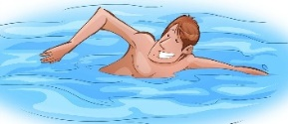
Dobro je plivati u moru.
It’s good to lie on a beach, too. 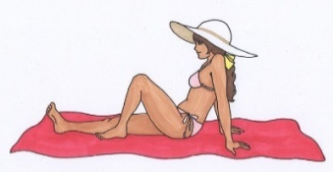
Također je dobro ležati na plaži.
But it’s better to swim in the sea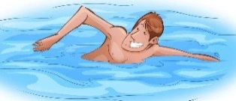
Ali, bolje je plivati u moru
than to lie on a beach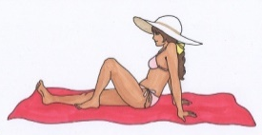.
nego ležati na plaži.

What is better?
Što je bolje?
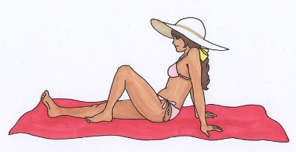
to swim in the sea to lie on a beach

- 6 a) Look at the pictures. Listen, point and say.
Pogledaj sličice. Poslušaj, pokaži i reci.

b) Read the sentences. Answer the question.
Circle the correct answer.
Pročitaj rečenice. Odgovori na pitanje. Zaokruži točan odgovor.
It’s bad to be in a desert without food. 
Loše je naći se u pustinji bez hrane.
It’s bad to be in a desert without water, too. 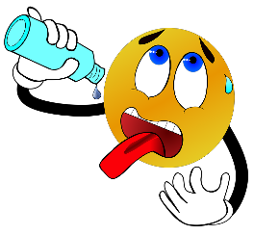
Također je loše naći se u pustinji bez vode.
But it’s worse to be in a desert without water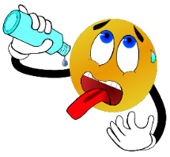
No, gore je naći se u pustinji bez vode.

than without food.
nego bez hrane.

What is worse?
Što je gore?
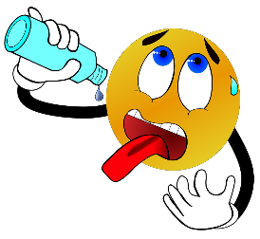
to be without food to be without water

Project. Projekt.
1 Choose a town in Croatia and compare it to Zagreb.
Go online. Answer the questions and compare the places
. Odgovori na pitanja i usporedi po dva različita mjesta.

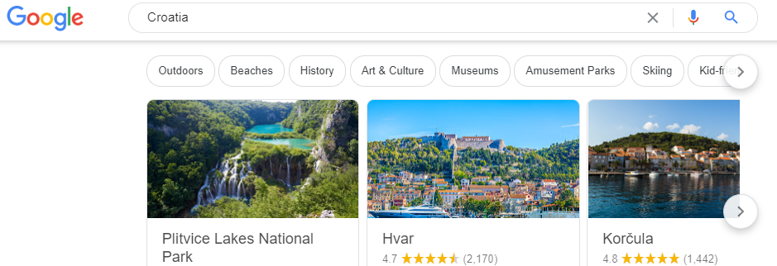

1 Which place is bigger?
Koje je mjesto veće?

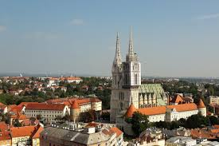
_____________ ZAGREB

Zagreb is bigger than _____________ .
Zagreb je veći od

2 Which place is COLDER?
Koje je mjesto hladnije?

_____________ is colder than _______________.
je hladniji od

3 Which place is cleaner?
Koje je mjesto čišće?

_____________ is colder than _______________.
je hladniji od

4 Which place is busier?
Koje je mjesto užurbanije?

_____________ is busier than _______________.
je užurbaniji od

5 Which place is noisier?
Koje je mjesto bučnije?

_____________ is noisier than _______________.
je bučniji od

6 Which place is better?
Koje je mjesto bolje?

_____________ is better than _______________.
je bolji od

